Welcome to Spark2, the Tribe weekly parsha activity sheet for Children’s Service Leaders across the United Synagogue communities.

Thank you for offering to run a service. The US is very proud of the numerous Children’s Services that are run every week across the UK and this would not happen without you.

Spark2 gives you an overview of the weekly parsha, a song, activity or Dvar Torah linked to the parsha or important event that week. Every children’s service will be different, in terms of how many participants there are, their age range, its length and the varying abilities of the children. Please read through the document and find the activities that will best suit the needs of your group. It is advisable to read it before Shabbat or Chag in case there is some preparation that may be needed in advance.

I hope you and the children at your service will benefit from Spark2. Please be in touch if you have any queries, feedback or if I can be of any help.

With best wishes,
Sharon Radley
sharonradley@tribeuk.com

SUCCOT

Background:

When the Jewish people left Egypt they wandered in the desert for forty years. In the desert they did not have houses to live in and they lived in huts. That’s why we build a Succah and live in it during the Chag of Succot. By going out of our secure homes we remember that God is our ultimate protection.

The Torah says:
‘You shall live in a Succah for seven days in order that your generations should know that God made you live in Succot when He bought the Jewish people out of Egypt.’

The festival of Succot is also called ‘Chag Ha’asif’ - the ‘Festival of the In-Gathering’. At the time of the Bet Hamikdash - the Temple, the Jewish people would go to Jerusalem at Succot and bring the produce of their fields. Since they walked from all over Eretz Yisrael, Succot was called a ‘Foot Festival.’
Succot is also called ‘Zeman Simchatenu’- ‘The Time of our Joy.’ We express our complete trust in God and celebrate our confidence in having received a good judgment from Him for the coming year.
The Succah:

Throughout the week of Succot we eat and socialize in the Succah. Some people even sleep in their Succah for seven nights! The Succah needs at least three walls of any material as long as they are sturdy enough to withstand normal wind. The walls of the Succah do not need to be especially built for Succot but can be walls that are already standing. The roof of the Succah - the S’chach, must be made from a material that grows from the

ground, for example, leaves or branches. There must be nothing overhanging the roof of the Succah. The roof must however give you more shade than sun during the day, but, be open enough for one to see stars through it at night.
We have the custom to decorate our Succah to beautify the mitzvah. It is also a tradition to welcome seven special guests known as the Ushpizin into our Succah throughout the chag. These guests are our great leaders, Avraham, Yitzchak, Yaakov, Moshe, Aaron, Yosef and David.
The Arba’ah Minim – Four Species:
The Torah tells us:
‘And you shall take for yourselves, on the first day, the fruit of a beautiful tree, branches of a date palm and the leaves of a myrtle tree and willow tree.’
The fruit of a beautiful tree is the etrog – a fragrant fruit with a thick white rind. It is often picked from the tree while it is green and then it ripens to a bright yellow.
The date palm is the lulav which has a straight shape and leaves tightly bound.
The myrtle branch is the hadas which has a beautiful plaited pattern of three leaves coming out from the same point.
The willow branch, the arava, should have oblong leaves with a smooth edge.
The two willow leaves are bound on the left of the lulav and the three myrtle leaves are bound on the right. When we lift them together with the etrog and wave them in all directions we show that God is Master of all Creations.

Each day, apart from Shabbat, we wave the Four Species in the synagogue during the Hallel prayer. This is followed by Hoshanot – circuits that encircle the bima.
Hoshana Raba:
The seventh day of Succot is called Hoshana Rabba. This day, our Rabbis tell us, is the very last moment that God decides what will happen to us over the coming year. The day features seven circuits around the bima, with the Four Species in hand. Towards the end of the service, bunches of willows are beaten to the ground while special prayers are said. These bunches are called Hoshanot which is derived from the word ‘to save.’ We ask God to save us.
Shemini Atzeret and Simchat Torah:
The eighth day of Succot starts a new Chag called Shemini Atzeret. In Eretz Yisrael this day is also the Chag of Simchat Torah. Outside of Eretz Yisrael, Simchat Torah is on the next day.
Shemini Atzeret means ‘The Assembly of the Eighth day’. Our Rabbis tell us that we have been with God over Tishrei so much that when all the Chagim are over He does not want us to leave and makes a special Chag for us to be with Him a little longer.
The final day, Simchat Torah – The Rejoicing of the Torah, is the day when we finish the annual cycle of reading the parshiot. We read the last parsha of the Torah, V’zot Habracha and start immediately with the first part of Bereshit. This reminds us that the Torah reading is a cycle that never ends.
Simchat Torah is a joyous occasion with lots of dancing and singing in the synagogue. There are processions called Hakafot around the synagogue with the Sifrei Torah. As many people as possible are given the honour of carrying a Sefer Torah in these Hakafot. For the reading of Parshat Vzot Habracha, every male (including boys under Bar Mitzvah age), are called to the Torah for an Aliyah.
Setting the Scene:
Most synagogues have a Succah and it would be a nice idea to take the children to have something to eat inside it. Please ensure that whatever is given to the children to eat conforms to your allergy guidelines.
Before eating, the children should first say the appropriate bracha for the food they are about to eat, followed by the bracha for eating in the Succah:
‘Baruch Ata Hashem, Elokenu Melech Ha’Olam Asher Kideshanu B’mitzvotav V’tzivanu Leshev b’Succah.’
If people are happy for their Lulav and Etrog to be used, it would be a lovely idea for all the children to have an opportunity to shake the Arba’ah Minim. Split the children into groups and assign an adult to each group. The adults should help the children say the brachot and shake the Four Species. The brachot and instructions for waving can be found on Page 188 of the Siddur Shevet Asher, Tribe Siddur for Children and Families. We do not wave the four species on Shabbat.

ACTIVITIES

Please choose the activities from the list below that are most suitable for the age range at your service.

Torah/Sefer/Parsha

On Simchat Torah we finish the last book of the Torah, Devarim, and immediately begin the Book of Bereshit, to signify that we never end the cycle of reading the Torah.
To give the children an understanding of how the Torah is organised into five books which are then divided into parshiot, it would be a nice idea to arrange in advance, to have three boxes that gradually increase in size. Explain to the children that the biggest box is like the Torah. (Show them the box and then open it up and take out the next size box – or even better, ask a child to open it up.) Explain that the Torah is divided into five books (each one being called a Sefer) and the next size box is like one of the books. Ask the children if they know the names of the books and say them aloud.
Finally open up the second box and take out the smallest box. Explain that each book/ sefer, is split up into parshiot. Each week we read one or two of the parshiot on Shabbat.
On Simchat Torah we finish reading the very last parasha – V’Zot Habracha, which is from the very last Sefer of Devarim. As soon as we finish it we start reading the parsha of Bereishit which is the first parsha in the Sefer of Bereishit!
To reinforce this ask the children to crouch down on the floor and make themselves as small as possible. You are going to call this shape the ‘Parsha shape’.
Now ask the children to make themselves slightly bigger. (Perhaps standing up straight.) This shape is going to be called the ‘Sefer shape’. Finally the children should stretch their arms up and out as wide as possible and stand with their legs apart so that they are in a star shape. You are going to call this the ‘Torah shape’.
Play a little game. When you call out ‘Parsha’, Sefer’ or ‘Torah’ the children form the corresponding shape. The last one to do this is ‘out’. Continue play until you have a winner!

Pass the Etrog
Sit the children in a circle and explain to the children that you are using two lemons instead of etrogim that are very precious. Ask one person to hold both lemons and when you say so they should pass one lemon to the person on their right and one to the person on their left. They must pass the lemons and not throw them. The aim of the game is to not be caught with both lemons at the same time but to try and make this happen to someone else. If this does happen then the person caught out should move out of the circle or cross their arms.

Don’t get caught in the Succah!
For this game you will need groups of three and one pair. Two people from each group join hands to form a "Succah" while the third person stands inside it. One person form the pair is told to chase the other and catch them. When the person being chased thinks they are about to be caught they may run inside the succah. The person who is inside it must then run out and take their place. You cannot enter a succah that you have just left. If a person is caught they then chase the captor.
Succot Letters
Ask the group to form a circle. Place a volunteer in the middle of the circle. Pass a small object around the circle. When the volunteer in the middle chooses to call out a letter the person holding the object at that point must shout out a word related to succot starting with that letter. The time they have to do this is the time it takes for the object to complete one rotation of the circle. If the link is tenuous you may ask the person to explain the connection to Succot. If you are happy with the link the person swaps seats with the person in the middle.
Kosher or Not?
Explain to the children that there are many laws written in the Talmud about what makes a Succah a kosher one or a non-kosher one. It is important for a Succah to be kosher because if it is not kosher and you sit in it and make the brachah, you are not fulfilling the mitzvah properly.
Ask the children if they know any of the laws of a kosher succah.
Explain the following rules briefly:
- A succah must be built under the sky with nothing between it and the sky. So, a succah cannot be built under an overhanging balcony or tree.
- A succah does not need a mezuzah as it is temporary.
- A succah should preferably measure at least 70cm long by 70cm wide.
- It must be at least 80cm high.
- There is no limit to the size of a succah but the roof must not be higher than approximately 10 m from the floor of the succah. A succah on top of a sky scraper would be kosher if the roof was not higher than 10 m above its floor!
- The succah must have at least three walls but one may be only 15cm wide.
- The wall of a succah must be made from material that will withstand normal wind.
- The roof – s’chach must be made from a material that grew from the ground and is no longer attached to the ground.
- You cannot steal branches or leaves from the countryside in order to fulfil the mitzvah of the succah.
- There must be enough s’chach to cover the majority of the roof but ideally, there should be sufficient spaces in the s'chach that one will be able to see some stars at night.
Split your participants into groups and print out enough copies of the pictures below so that each group has a set. (Pictures courtesy of Neot Kedomim Israel.) Give each group a few minutes to have a look at the pictures and decide if they are kosher or not. Give each group a red and green piece of card (or two cards of any colour).
When time is up ask each group to choose a spokesman. The job of the spokesman will be to hold up the green card if the group has decided a succah is kosher and a red card if they have decided it is not kosher. Go through each succah and ask for the spokesmen to hold up their cards. Groups that have chosen correctly will win a point. The team with the most points wins. (Answers are below. Make sure you do not accidently give the groups the answers when you give out the pictures!)
ANSWERS

- Not kosher – the roof is too high above the floor of the succah.
- Too small – not kosher.
- A succah on a camel is kosher but only on Chol Hamoed – the intermediary days - as on Yom Tov and Shabbat we are not permitted to ride an animal.
- A succah on a boat is kosher.
- The s’chach must be something that once grew in the ground but is no longer attached to the ground. In this picture the s’chach is still growing so the succah is not kosher.
- The roof is too high above the ground of the succah so it is not kosher.
- This is kosher but not on Shabbat or Yom Tov as we are not permitted to climb trees on those days.
- Kosher
- Not kosher as there are not enough walls.

1.
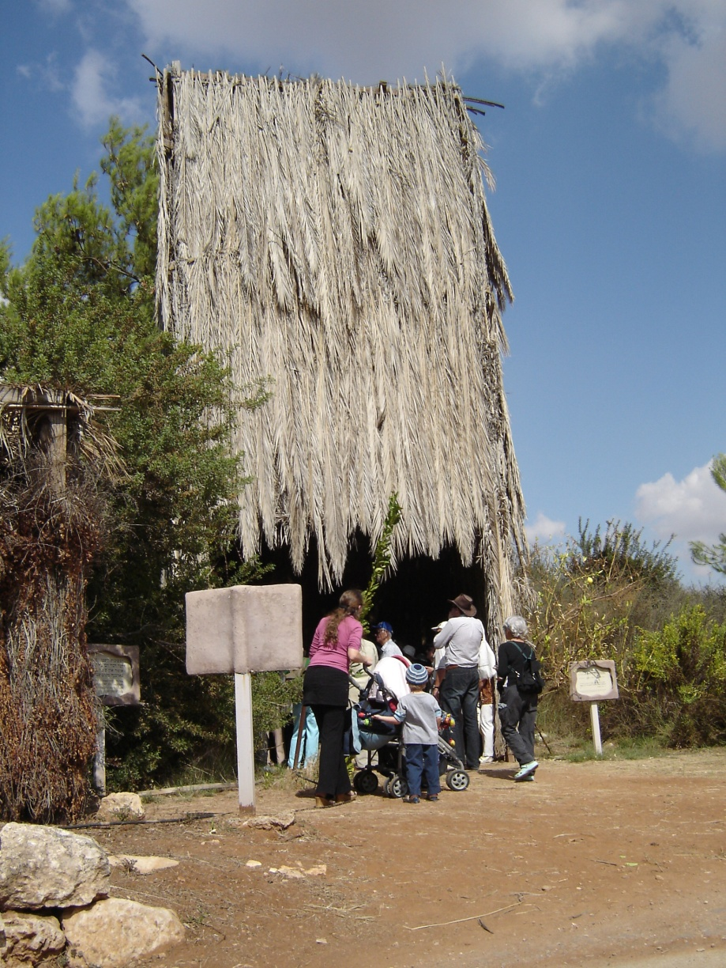

2.
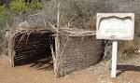

3.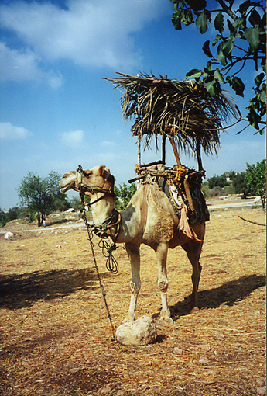

4.
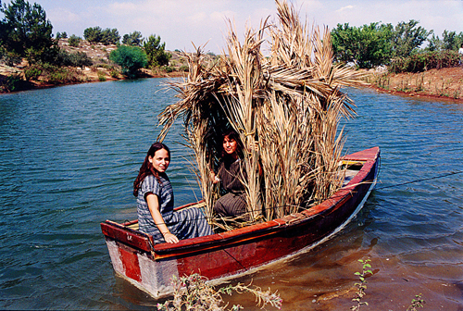

5.
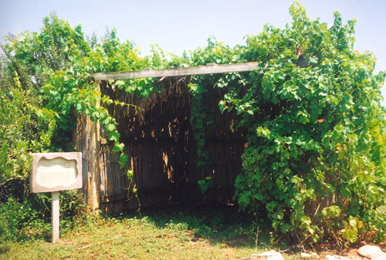

6.
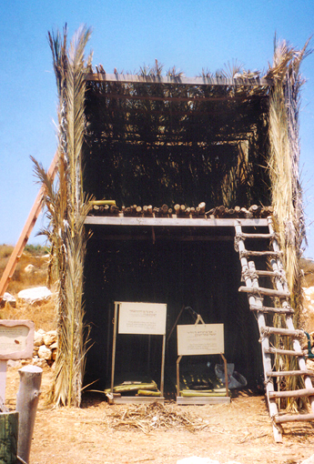

7.
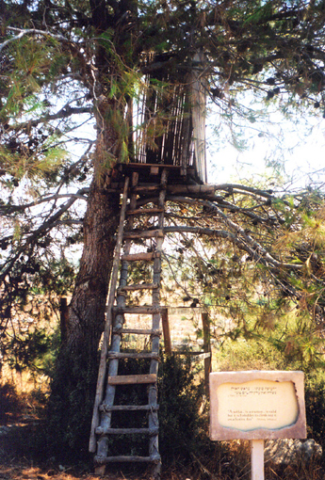

8.
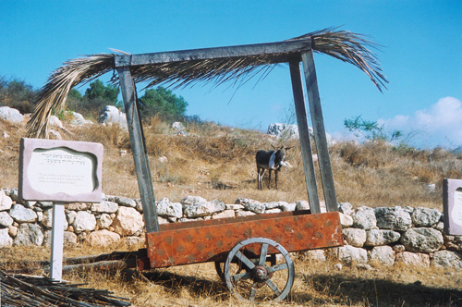

9.
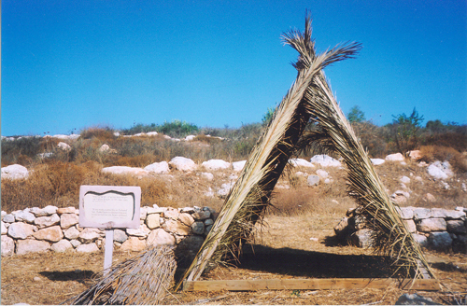

Story
The Etrog
It was the day before Succot. Sara and David went to the special Succot shop with their uncle to help him choose his Arba’ah Minim – the lulav, etrog, hadasim and aravot.
The shop was packed full of people buying their last minute Succot items. Their uncle looked at the lulavim very carefully until he found one that he liked. It was tall and straight.
Next he started to look for his etrog. That took even longer. In the end he found one with which he was really pleased. It was a lovely yellow colour and a great shape. Sara and David were allowed to smell it before it was carefully wrapped up and placed in a special box.
When the hadassim and aravot were chosen it was almost time to go. The children’s uncle allowed them each to choose a special decoration for their succah at home. Sara chose some fairy lights to hang from the sechach and David chose a poster of the Kotel.
When their uncle had paid for everything they went back to his home. He put the Arba’ah Minim on the table and told the children not to touch them. He went out of the room to carry on work on his succah.
David said to Sara, ‘Let’s have another look at the etrog’. I really want to smell it again. ‘
Sara said, “We are not supposed to touch it, we were told to leave it alone.”
“Oh come on, let’s just look at it quickly and put it back as fast as we can. No one will know,” said her brother.
He went to the table and opened up the etrog box. Peeling back the layers of the special straw that encased the etrog, he pulled it out and sniffed it.
“Come on Sara have a smell, its lovely,” he said.
Sara walked over to the table and took the etrog from his hand but, somehow she missed and she dropped it on the floor!
David and Sara were horrified! They knew that you had to be very careful with an etrog and that you must not drop it in case the little bit at the end called the pitom would break off. If the pitom broke off, their uncle’s etrog wouldn’t be kosher anymore and he wouldn’t be able to use it. They searched on their hands and knees all over the floor to see if they could find the pitom but they couldn’t find it. What were they to do?
They decided to sneak out of the house and run back to the shop and speak to the owner. Perhaps he had a spare etrog he could give them?
They ran as fast as they could and arrived at the shop. The etrog seller was still there serving some customers. Politely they waited until he was finished and then they showed him the broken etrog. “What should we do?” they asked him.
Carefully the man looked at the etrog and a big smile crossed his face. “Children, this etrog is a special etrog! It never had a pitom on it in the first place! Some etrogim grow with their pitom inside them and they are kosher too. Your uncle is fine to use this etrog” he said.
David and Sara were thrilled. Happily they ran back to their uncle’s house and inserted the etrog back in its box before anyone found out.
From that day on they never played with an etrog again!

Ushpezin Discussion

The children should sit in a circle and you should explain the idea of the Ushpezin to them. As mentioned above, we have the tradition on succot, to welcome 7 guests – leaders of the Jewish people, into our temporary “home.” As a group, discuss which 7 people they would like to invite to their succah and why. The guests could range from historical characters to ancestors as well as modern role models. You could also add your own ideas to the group to give the children some food for thought.

Succot Quiz

Please find below a section with some quiz questions on Succot and beneath it some based on Shmini Atzeret and Simchat Torah.
Run the quiz however works best for you, but you may want to split the children into two groups and ask alternating questions to each group, to make the quiz into a competition.
In order to simplify the questions you may want to make them into multiple choice questions. This will depend on the level of knowledge of the children at your service. You may also want children to think of questions for their opposing team.

1. What is the literal meaning of the word Succot?
2. What is the Hebrew date of the start of Succot?
3. When is it traditional to start building the Succah?
4. What is the maximum width of a Succah?
5. What does Succot commemorate?
6. What is the combined number of days for the Succot, Shemini Atzeret and Simchat Torah festivals?
7. In how many different directions do we shake the lulav and etrog?
8. Which are the ‘Shalosh Regalim’ (Three foot festivals?)
9. When constructing the s’chach (roof) on the Succah, should it allow in more shade, more sunlight, or equal amounts of both?
10. What is another name for Succot?
11. What does the word Etrog literally mean?
12. What is the seventh day of Succot called?
13. How many Hadassim and Aravot should we hold with the Lulav?
14. What does the Aramaic word Ushpizin mean?
15. In which of the following places is building a succah not allowed? Under a tree, on a ship, on a tall building, on top of a mountain?
16. The Lulav bundle is made from the branches of three different types of trees bound together, what are they?

Answers
1. Huts or booths
2. 15th of Tishrei
3. Straight after Yom Kippur is finished
4. It can be as wide as you want, there is no limit.
5. When the Children of Israel lived in temporary huts, on their journey through the desert towards Israel
6. 8 days in Israel, 9 everywhere else
7. 6 (up, down, right, left, forwards and backwards)
8. Pesach, Shavuot, Succot
9. More shade than sunlight
10. ‘Zaman Simchateinu’ –‘The Season of our Rejoicing’
11. Pleasant
12. Hoshana Rabbah
13. Three Hadassim, two Aravot
14. Guests
15. Under a tree
16. Palm, Willow, Myrtle

Shemini Atzeret/Simchat Torah Quiz

1. What does Shemini Atzeret mean?
2. What is the Hebrew date of Shemini Atzeret?
3. Do we shake the Lulav on Shemini Atzeret?
4. Where does the commandment to observe Shemini Atzeret come from?
5. Shemini Atzeret marks the beginning of what season in Israel?
6. On Shemini Atzeret, a short prayer for rain is added to the Musaf service. What is this prayer called?
7. We say an additional prayer for rain every day after Shemini Atzeret. Until when does this prayer for rain continue to be recited?
8. How long does it take to read the entire Torah?
9. What do we celebrate on Simchat Torah?
10. Why do we eat lots of sweets on Simchat Torah?
11. True or false; Simchat Torah is the only time that children under the age of 13 are allowed to make a blessing over the Torah?
12. On Simchat Torah, what are the circuits made while holding the Torah and dancing around the synagogue called?
13. How many times do we dance the Sefer Torah around the bimah on Simchat Torah?
14. On Simchat Torah, the custom is for how many people to be honoured with an aliyah (call up to the Torah)?
15. What does Kol Hanearim mean?
16. During the morning service of Simchat Torah, how many Torah portions are read?
17. What are the names of the portions we read in the morning service on Simchat Torah and where can they be found in the Torah Scroll?
18. True or false: In synagogue, Simchat Torah is the only time that the Torah is read at night.
19. Why do we hold a tallit over the heads of the people who are reading from the Torah?

Answers
1. The Eighth Day of Assembly
2. 22nd Tishrei
3. No
4. The Torah
5. The rainy season
6. Tefillat Geshem
7. The first day of Pesach
8. 1 year
9. The completion of the reading of the Torah
10. To remind us how sweet it is to study and keep the Torah
11. True
12. Hakafot
13. 7
14. All the men and children in the congregation
15. All the young ones. This is the blessing on the Torah that all the children make.
16. 2
17. The very last portion right at the end, V’zot Habracha; and the very first portion right at the beginning, Bereshit
18. True
19. It reminds us of the Chuppah (wedding canopy), and symbolises that through the Torah, we wed ourselves to God.

Five Books

On Simchat Torah we finish reading the entire Torah. The following game will help the children remember the names of the Five Books.

Split the room into five areas and assign each area one of the names of the books of the Torah. (Bereshit, Shemot, Vayikra, Bamidbar and Devarim.) When you call the names of one of the books all the children should run to that area. The last child there is out, as is the child who ran to the wrong place.
If you call out Simchat Torah (at any time) all the children must sit down whatever they are doing. The last one sitting is out.
The last remaining child or children are the winners.
Please only play this game in a safe place.

