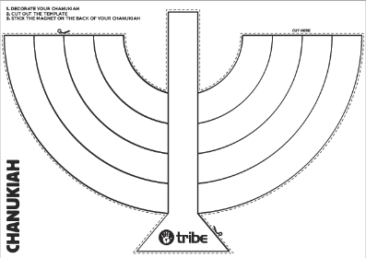

How to make your Tribe Chanukiah
You will need:
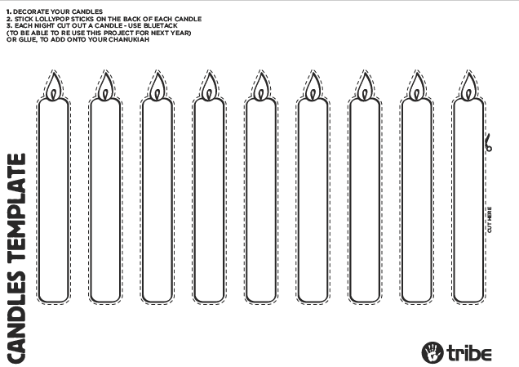
- 1 template of chanukiah (using the online link download)
- 1 candle template double sided
- 9 lolly sticks
- 1 blob of blue tack
- Glue
- Colouring pens/pencils
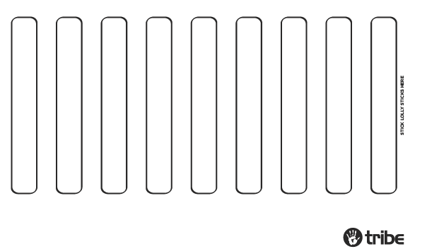
- Magnet – optional
- Scissors

Steps:
- Colour in your chanukiah
- Colour in your candles
- Cut out your chanukiah along the dotted lines
- Turn over your candle sheet and stick the lolly sticks in the spaces marked
- (optional) Stick your magnet on the back of your chanukiah and put on your fridge
- Each night, cut out a candle and stick it to your chanukiah with a bit of blue tack (or glue)
- At the end of Chanukah you can take the candles off and save everything to use again next year!

Send a picture of your creations to info@tribeuk.com

