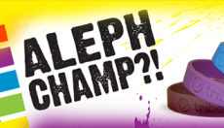

Aleph Champ
The Aleph Champ Programme is an exciting Hebrew reading scheme based on the karate motivational system of colours, levels and tests. The entire reading system is divided into nine coloured levels. This arrangement ensures that students learn to read Hebrew in an efficient, well organised and structured manner. The children are motivated to pass each level by collecting wristbands of each colour.
The programme consists of nine reading books, eight workbooks, 6 sets of flashcards, a script workbook, wristbands for each colour and a homework diary. At the beginning of each reading book there is a clear learning objective stating what the child should gain from each level and a test at the back of each book to ensure that students only progress to a new level once they have mastered the previous one. This helps to avoid the common problem of children learning to read without fully mastering a letter, vowel or principle of reading.

Materials
- Reading books (£4.40 each)
There are nine reading books: white, red, orange, yellow, green, blue, purple, brown and grey. The reading books are re usable and can be passed from one student class to the next.
- Workbooks (£4.40 each)
There are eight workbooks white, red, orange, yellow, green, blue, purple and brown. These can be used for practise to support the reading books.
- Flashcards (£27.50 per set)
There are six sets of flashcards orange, yellow, green, blue, purple and brown. Each set consists of 20 cards and can be used to practise words that are covered in the corresponding reading book of that colour.
- Script workbook (£7.70)
There is one script workbook which should only be used once all workbooks and colours are complete. It teaches how to recognise script letters and write and practise the letters and words.
- Wristbands (£2 per 9 bands)
There are nine coloured wristbands to use as motivation to collect once a level has been passed.
- Homework diary (75p)
Set work and monitor when complete.

What each level covers
- White
The first 19 letters of the Aleph Bet
- Red
The last 13 letters of the Aleph Bet. Recognise and master all 32 letters of the Aleph Bet
- Orange
Learn the first three vowels and blend with letters. Kamatz, Patach and Tzeireh
- Yellow
Learn the next three vowels and blend with letters. Segol, Sh’va and Cholam
- Green
Learn the next three vowels and blend with letters. Chirik, Kubutz and Shuruk
- Blue
Learn Hebrew reading exceptions to the rule. Chataf Kamatz, Chataf Patach and Chataf Segol
- Purple
Weekday prayer recognition, fluency and speed. New vowel sounds/exceptions to the rule
- Brown
Shabbat prayer recognition, fluency and speed
- Grey
Festival prayer recognition, fluency and speed. New vowel sounds Kamatz Katan

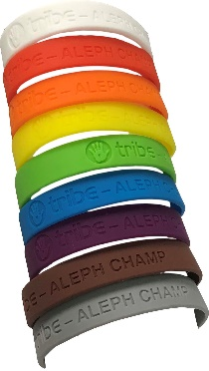
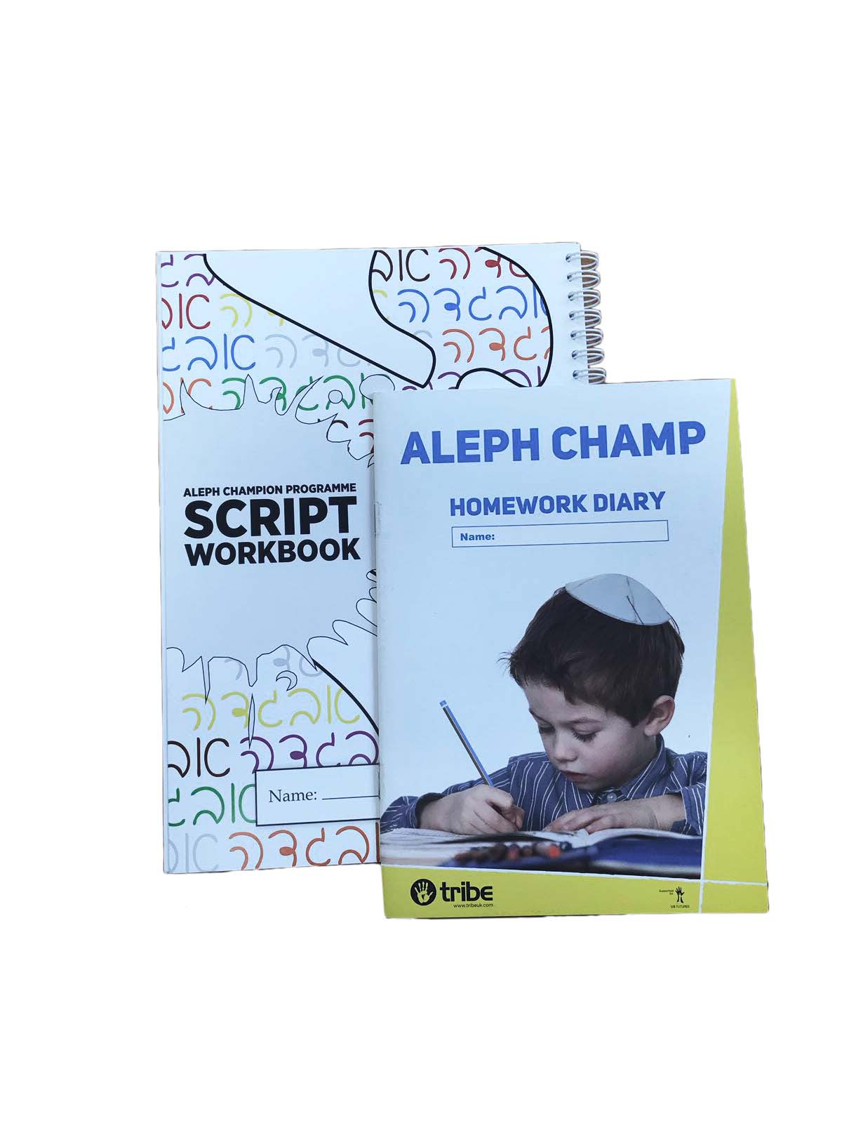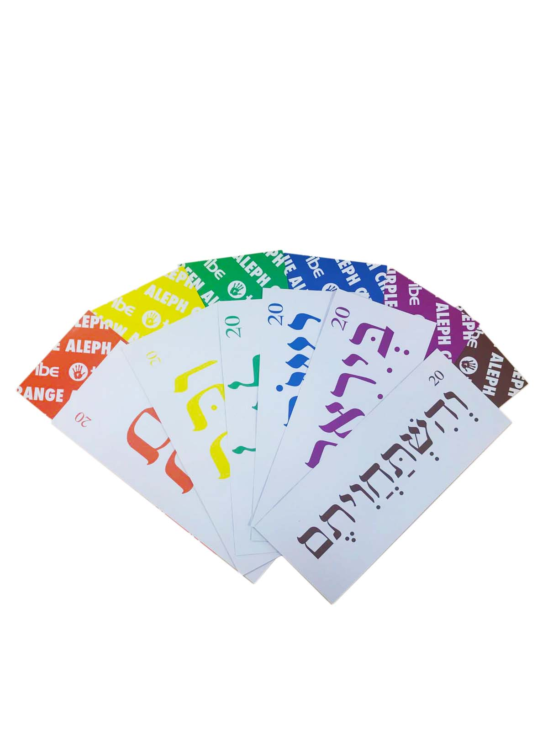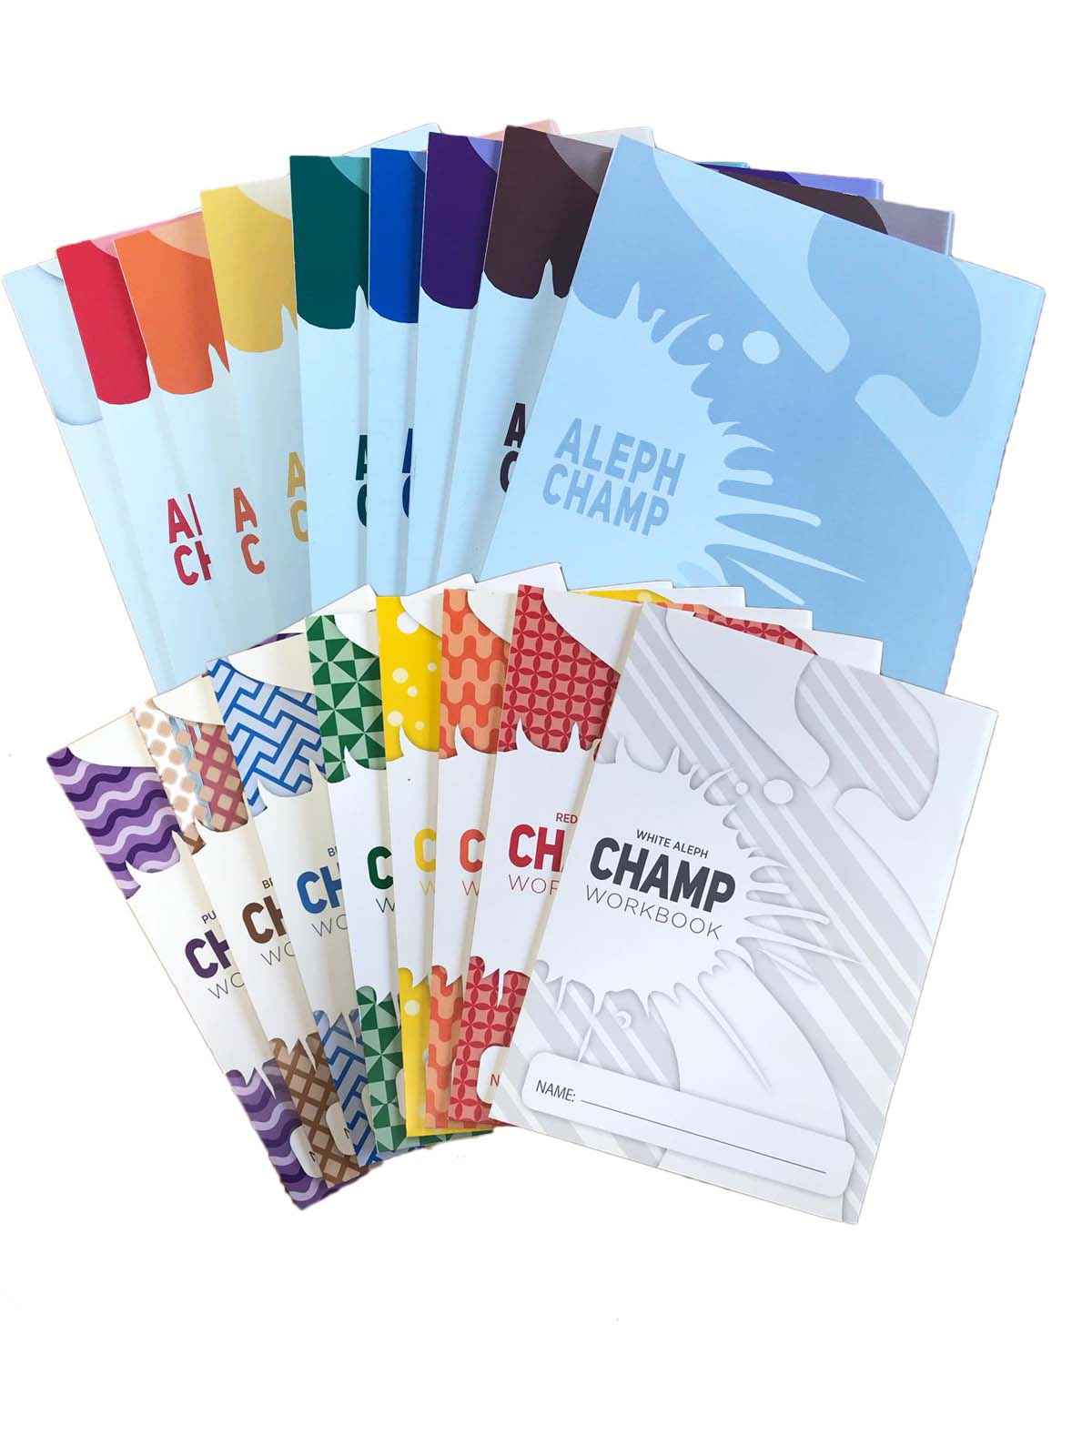To enquire about Aleph champ or to make an order please email publications@theus.org.uk

